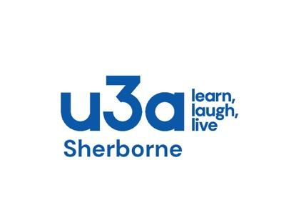

MEMBERSHIP ENROLMENT FORM and GIFT AID DECLARATION

Title: | First Name: |  |  | Surname:
Address:
 |  |  |  |  |  | Post Code:
Telephone No.: |  | Mobile.: |  | e-mail address:
As a member of Sherborne U3A you are eligible to receive copies of Third Age Matters, the national U3A magazine.
If you wish to receive this, please tick this box. Please note that if you opt to receive the magazine, your name and address will be supplied to the company that distributes it.

Data Protection
Your details will be stored on a computer database which is managed in accordance with the Sherborne U3A Privacy Policy, a copy of which is available from the Membership Secretary or from the Sherborne U3A website.

DECLARATION
I wish to become a member of Sherborne U3A from now until 31st August 2026.

Signature: ………………………………………………………… Date: ……………………….……

Please submit this form, together with your subscription fee of £20 (£10 after 31st March 2026) to
The Membership Secretary, John Dale
Dunelm, North Street, Bradford Abbas, Dorset, DT9 6SA
Cheques should be made payable to 'Sherborne U3A'. If you wish to pay by electronic bank transfer, please send your payment to 'Sherborne U3A', account number 93645495 at sort code 20-68-15. Do not combine multiple items into a single payment, but make a separate payment for each item, as that will help our accounting. Give your payment a reference of the first 4 or 5 letters of your surname. Please also send the treasurer the briefest of emails at 'treasurer.sherborneu3a@gmail.com' to let him know the amount and date on which you have made payment.
If you are not on email, please enclose a stamped self-addressed envelope to facilitate the return of your membership confirmation.

